ABBREVIATIONS USED IN OPHTHALMOLOGY
For Staff Use

ANATOMY

OU – both eyes (latin oculus uterque)
OD – right eye (latin oculus dexter)
OS – left eye (latin oculus sinister)

MUSCLES OF THE EYE

Lateral is used to describe things on the outside, which in ophthalmic terms would be temperal, medial (nasal) superior (above) and inferior (below).

SR – superior rectus
IR inferior rectus
MR – medial recus
LR – lateral rectus
SO – Superior Oblique
IO – Inferior Oblique

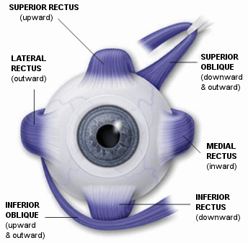

Sclera – The White of the eye is a fibrous protective outer layer of the eye.
Cornea – The cornea is the transparent front part of the eye that covers the iris, pupil and anterior chamber
Choroid – This is made up of layers of blood vessels which nourish the eye
CB – Ciliary Body – The ciliary body has three functions; accommodation, aqueous humour production and the production and maintenance of the lens zonules
Iris – The coloured part of the eye which controls pupil size
Pupil – This is the black part of the eye which allows light to enter
Retina – The nerve layer lining the back of the eye. The retina senses light and creates electrical impulses that are sent through the optic nerve to the brain
Macula – This is the area of the eye responsible for central vision ie. Close work, detailing, colours etc.
Otpic Nerve – This is where all the electrical signals are fed through to the brain from the back of the eye
Optic Disc – The optic disc is where the retinal aqueous, vitreous humour and optic nerve enter and exit the eye. The optic disc has no photo receptors and therefore marks the blind spot of the eye
Vitreous Humour – This is the jelly like substance which fills the gap between the lens and the retina
Aqueous Humour – The aqueous humour is a thick watery substance filling the space between the lens and the cornea. Its purpose is to maintain intraocular pressure and provide nourishment for the avascular ocular tissues
Canal of Schlemm – This is a circular channel in the eye that collects aqueous humour from the anterior chamber and delivers it into the bloodstream
Lens – The lens is a transparent biconvex structure in the eye that helps to reflect light onto the retina
Conjunctiva – This is a clear mucus membrane that covers the sclera. Its purpose is to lubricate the eye by producing mucous and tears

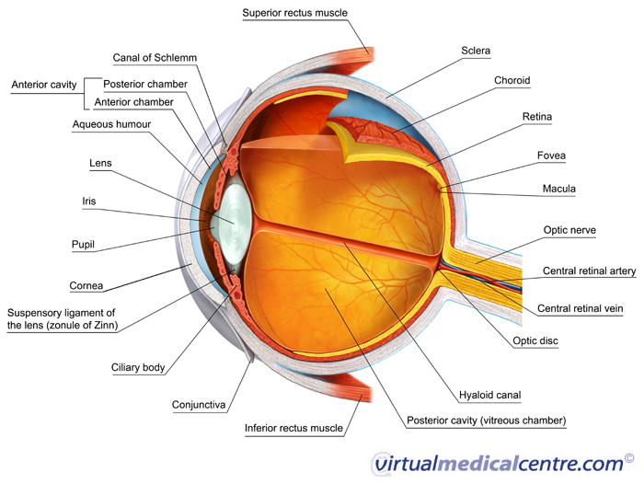

EXAM

VA visual acuity (using snellen chart usually)
CC – with refractive correction
SC – Without refractive correction
PH – Pinhole va
PHNI – Pinhole No Improvement
NI – No Improvement
CF – Count fingers
HM – Hand Movement
PL – Passing light
NLP – No light perception
CSN – Central, steady, maintained
F + F – Fixes and follows
BCVA – Best corrected visual acuity

REFRACTION

WRx – wearing RX
ARx – auto refraction
MRx – Manifest refraction
CRx – Cycloplegic refraction
NRx –near refraction
Add – amount of plus prescription needed for reading or close work
R – retinoscopy
Rc – Cycloplegic retinoscopy
Sph – Sphere
Cyl – Cylinder
Ax – Axis
PD – papillary distance

ALLIGNMENT OF THE EYES

E – Esophoria (inward deviation)
ET – Esotropia (squint)
E(T) – Intermittent esotropia
X – Exophoria (outward deviation)
XT – Exotropia (outward deviation)
X(T) – Intermittent exotropia
HT – Hypertropia – is a condition of misalignment of the eyes (strabismus) whereby the visual axis of one eye is higher than the fellow fixating eye
HoT – Hypotropia – is a similar condition to hypertropia, focus being on the eye with the visual axis lower than the fellow fixating eye

EXTERNAL

APD/RADP – Afferent papillary defect, relative afferent papillary defect (types of pupil response to light)
IOP – Intra ocular pressure
T – tonometry
Ta – Goldmann Tonometry
CCT/pachy – central corneal thickness/pachymetry
SLE – Slit lamp exam
K – Cornea
AC – Anterior chamber
D & Q – Deep and quiet
I – Iris
ACIOL – Anterior chamber intraocular lens
PCIOL – Posterior chamber intraocular lens
DFE/UDFE – Dilated/Undilated fundus examination
C/D – Cup / disc ratio

CORNEA

PEE – Punctate epithelial erosion – is characterised by a breakdown or damage of the corneal epithelium in a pinpoint pattern, which can be seen with examination by slit lamp
BK – Band keratopathy – a corneal disease derived from the appearance of calcium of the the central cornea
ED – Epithelial defect
KP – Keratic Precipitate
EKC – Epidemic Kerataconjunctivitis – the inflammation of the cornea and conjunctiva caused by adenovirus. When only the cornea is inflamed it is called keratitis. When only the conjunctiva is inflamed it is conjunctivitis
KC – Kerataconus – is a degenerative disorder of the eye whereby structural changes in the cornea cause it to thin and change to become more conical in shape than its normal gradual curve. This usually causes patients to have a large astigmatism in their prescription
FB – Foreign body

GLAUCOMA

OAG – Open angle glaucoma – Glaucome is an eye disorder in which the optic nerve suffers damage, permanently impacting vision in the affected eye and progressing to complete blindness is untreated. It is often, but not always, associated with increased pressure of the fluid in the eye (aqueous humour). Open angle is a slower and more common form.
CAG – this usually presents as a painful eye with very high pressures. Patients may also have red eyes, see halos of light and feel generally unwell, which usually prompts them to seek medical advice
JOAG – Juvenile open angle glaucoma –
NVG – Neovascular glaucoma – results when new, abnormal vessels begin developing in the angle of the eye, which block the eyes drainage system. Patients with such conditions begin to rapidly lose their eyesight
OHT – Ocular hypertension
NGT/LTG – Normal / Low tension Glaucoma
Trab – Trabeculoctomy – a surgical procedure used in the treatment of glaucoma to relive interocular pressure by removing part of the eyes trabecular meshwork and adjacent structures
AVx – Anterior vitrectomy – a surgery to remove some or all of the vitreous humour from the eye. Anterior vitrectomy entails removing small portions of the vitreaous from the front structure of the eye, often because these are tangled in an intraocular lens or other structures
ALT – Argon laser trabeculorplasty
ONHD – Optic nerve head drusen

CATARACT

IOL – intraocular lens – artificial lens inserted in cataract surgery
Phaco – Phaco emulsification – refers to modern cateract surgery in which the eyes internal lens is emulsified with and ultrasonic hand piece and aspirated from the eye
PCO – Posterior capsular opacity – clouding of the IOL usually treated with the Yag laser
ACC – Anterior cortical changes (cataract)
NS – Nuclear sclerosis
PCC – Posterior cortical changes
PSC – Posterior subcapsular cateract

RETINA

CMO/E – Cystoid macular oedema/edema
CSMO/CSME – Clinically significant macular oedema/edema

BRVO – branch retinal vein occlusion
BRAO - branch retinal artery occlusion
CRVO – Central retinal vein occlusion
CRAO – Central retinal artery occlusion

Occulsions caused by blockages can lead to ischemic problems as the retina is starved of blood.

BDR – Background diabetic retinopathy – early changes
PPDR – Preprolific diabetic retinopathy – stage before new blood vessels start to grow
PDR – Prolific diabetic retinopathy – when the new vessels grow. These blood vessels are very delicate and can bleed easily. Laser is very effective in stopping the new vessels from growing
AMD/ARMD – Age related macular degeneration – is a medical sonditions which usually affects older adults and results in loss of vision in the centre of the visual field (the macular) because of damage to the retina. It occurs in dry and wet forms
IRMA – Intra retinal microvascular abnormalities
ERM – Epiretinal membrane – occurs when a layer of scar tissue develops on the surface of the macular. This scar tissue then contracts and in doing so causes the retina to “crumple”
RD – Retinal detachment – is a disorder of the eye in which the retian peels away from its underlying layer of support tissue
PVD – Posterior vitreous detachment
VMT – Vitreomacular traction
CNV – Choroidal neovascularisation – is the creation of new blood vessels in the choroid layer of eye
CNVM – Choroidal neovascular membrane
PED – Pigment epithelial detachment
VH – Vitreous haemorrhage
CSCR – central serous chorioretinopathy
NVD – Neovascularisation of the disc – new blood vessels
NVE – neovascularisation elsewhere
CWS – cotton wool spots – abnormal findings on fundoscopic exam of the retina of the eye. They appear as puffy white patches on the retina and are cause by damage to nerve fibres or may be referred to as macro infarct
MM – Malignant melanoma
IML – Indeterminant malignant lesion
CHRPE – Congenital Hypertrophy of the retinal pigment epithelium

NEURO

PPA – Peripapillary atrophy (thinning)
ION – Ischemic optic neuropathy – cause by poor blood flow
AION – Anterior ischemic optic neuropathy
PION – Posterior ischemic optic neuropathy
IIH – Idiopathic intracranical hypertension
TON – Traumatic optic neuropathy
MS – Multiple Sclerosis
CGA – Giant cell arthritis
PXE – Pseudoxanthoma elasticum (genetic disease which can lead to amongst other things angiod streaks)

TESTS

FA – Flourescein angiogram
OCT – Optical coherence tomography
OCTNFL – OCT of the nerve fibre layer
HRT – Heidleberg retinal tomography
ERG – Electroretinogram
EOG – Electrooculogram
VF – Visual fields (usually Humphrey)
GFV – Goldmann visual fields

OTHERS

Ax – Allergies
IV – Intravenous
IM – Intramuscular
CVS – Cardiovascular system
CXR – Chest X ray
FBC – Full blood count
Dx – Drug history
LVA – Low vision aid
POH – previous ophthalmic history
PMH – Past medical history
Sx - Symptoms

