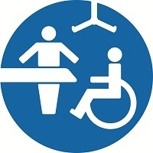‘CHANGING PLACES’
FACILITY AVAILABLE AT THIS HOSPITAL
LOCATED IN THE SCARSDALE WING

